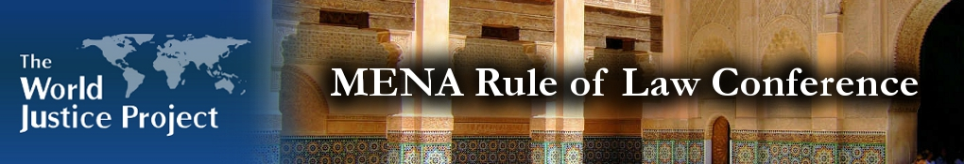
Equal Access to Water Rights Session at WPJ MENA Rule of Law Conference:

The World Justice Project (WJP) held its first major Conference in the Middle East and North Africa (MENA) region on June 25-26, 2010, in Ifrane, Morocco. Over 150 regional leaders from a breadth of disciplines convened to address Rule of Law issues relevant to the MENA region and to raise awareness concerning the impact that the Rule of Law has on all aspects of the community. This multidisciplinary, action-oriented Conference represents a distinct opportunity to promote interdisciplinary understanding of Access to Justice Challenges, to incubate sustainable actions, and to have long-lasting impact in the region.

Equal Access to Water Rights Session was Moderated by Dr. Walid Saleh, Regional Coordinator, MENA, United Nations University-Institute on Water, Environment, and Health (UNU-INWEH), UAE, and Dr. Jauad El Kharraz, Information Manager, EMWIS Technical Unit, Euro Mediterranean Water Information System, France, acted as the Reporter. Dr. Saleh as a moderator for the working session on “Equal Access to Water Rights,” led the group’s discussion to develop multidisciplinary action plans to strengthen the Rule of Law in this issue area. Equal access to water rights is a global issue which has immediate relevance for the Middle East and North Africa region. The implications of an effective partnership system which not only serves local communities but provides for regional needs are truly cataclysmic. This working session brought together leading stakeholders – including business, government, academics, and civil society – in concerted efforts to strengthen fair regulatory systems, share best practices, and ensure effective service delivery.

Key Rule of Law Identified Issues were:

- Harmonization of MENA water laws: Water laws toolkit;

- Good water resource governance;

- Training on water law issues;

- Raising water awareness and promote access to water as a human right issue;

- Negotiation skills on transboundary waters.

For farther information please contact Dr. Walid Saleh at salehw@inweh.unu.edu, or Dr. Jauad El Kharraz at jauad.el-kharraz@semide.org

